**Meeting Minutes**

Date: April 19, 2017

Place: Project Room 1, ERC

Team: Dr. Stranger

Attendants: Jiacheng CHEN, Jiahuan HE, Jiayu WANG, Yiming JIANG

Brief: Our team celebrated the milestone that had been achieved, confirmed the time for next meeting, planned individual tasks for the coming week, and discussed a few advanced features for the project.

1. **Celebrate the achievements**

Prior to the meeting, we celebrated what had been achieved so far, which was a working system with all the basic functions.

1. **Arrange time for next meeting**

Since next week is the break week, we rearranged the meeting to this Saturday (April 15).

1. **Review Previous Tasks**

We reviewed tasks had been done in last week, including a client side with marshalling function and a server side with all six required functions. The client side and server side could establish connection and deal with basic commands.

1. **Task Allocation**

For this week, we would start by self-testing. Then, we would establish a full list of test cases and start an overall testing. After that, we may try to discuss and implement advanced features like scalability, concurrency, reliability, and failure models.

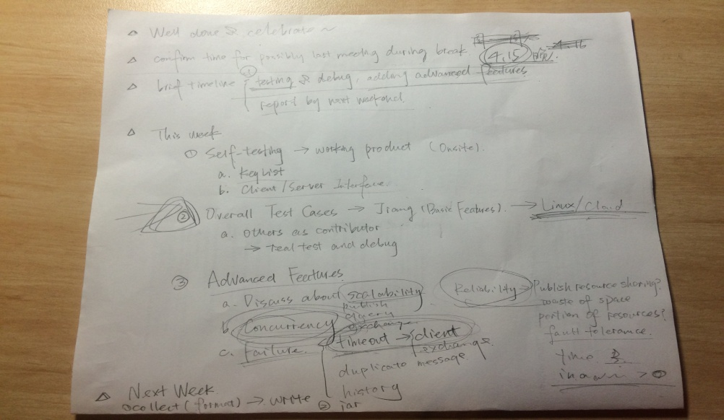

***Pic 4.1* Agenda and Task Allocation Draft**

We had made the following specified allocation:

Jiacheng CHEN : self-testing PUBLISH and SHARE function and testing according to test cases

Jiahuan HE : self-testing FETCH and REMOVE function and testing according to test cases

Jiayu WANG : adding timer and secret to server, testing QUERY&EXCHANGE functions, consult tutors

Yiming JIANG : generate test cases, add timeout to client, consult tutors